Title of Extended Abstract for the PRACTICE track of Product Life Cycle Modelling, Simulation and Synthesis (PLMSS)- 2021
ProductLifeCycle – SpaceSystemsPerspective
Author*¹, Co-author², Co-author^{x}
¹Affiliation details (Department and University/Institution/Organization, Country name)
²Affiliation details (Department and University/Institution/Organization, Country name)
^{x} Please add as many number of co-authors if required. There is no restriction on the no. of co-authors

ABSTRACT / EXECUTIVE SUMMARY

- What is the purpose of this STUDY?
- Clear statement of Problem
- Methodology adopted
- Salient results

This document presents the instructions needed to prepare the extended abstract to be included in the proceedings of the PLMSS2021. All abstracts should only be written in English. The extended abstract should be submitted in Microsoft Word format minimum 2 pages. It should start with the paper’s title, authors, address, followed by the Abstract's text and the keywords (up to five). Please, indicate the author who will present the paper with an asterisk (*). Abstract can include table, picture, figure, etc.Please, briefly explain the aim and scope of your study, your materials and methods, typical results and the main conclusions of the study. The abstract should be written in MS Word format in single-spaced in 11 point Times New Roman. Authors are requested to submit extended abstracts in electronic form (MS-Word) via conference website link in easy chair application.The scientific committee will read your abstracts and select the abstract for full paper submission and presentation typeas oral and poster presentations. However, the incorrect formats may result in your abstract not being selected. The selected full text papers [presented in the conference] may be considered for publishing in the journals supporting the PLMSS2021. All extended abstracts registered will be published in the conference proceeding e-book. Authors must submit the extended abstracts by using the online submission system. After logging in as an author, you have to upload your paper to the submission system.

Keywords: Abstract, Template, up to 5 words arranged in alphabetical order.

- INTRODUCTION

- What is the context (or background) of the study? (What has prompted this study?)
- What is the problem? (Answer this in one clear statement if possible.)
- What factors (e.g., stakeholders, timelines, underlying issues) should be considered in developing a recommendation?
- What recommendation(s) are you making?
- How will you support your recommendations in your study?

Extended abstracts/full papers will be published in the electronic conference proceeding book. Papers must be in good, grammatically correct English. All pages must be numbered.

Major headings are typed bold in 12pt upper case (capital letters), with two lines space above and below. Text should be justified (extend to the right-hand margin) and be typed to fill the full depth of the text area. Please, use a single-spaced 12pt Times New Roman typeface. Do not indent the text paragraphs. Official language of the conference is English.

- ANALYSIS

- Examine the problem being faced—what are the contributing factors?
- Show us the steps you’ve used to reach your recommendation and implementation plan.
- How do METHODS / CONCEPTS apply to the case?

Outline the METHODS / CONCEPTS used in your study here.

  - Minor headings

Minor headings are in 12pt bold-italic type, not indented, with one line of space above and below. Do not number headings.

  - Minor headings

New paragraphs are not indented, but are preceded by a line of space. Also please avoid using footnotes or splitting tables over two (or more) pages.

- RESULTS AND DISCUSSION

Describe and discuss your all results here and/or the finding/contents of your study. You can present tables, graphs and figures in this part.

Table 1. This is an example of table layout. It shows the dimensions of the text area. Note that a minimum number of horizontal rules and (usually) no vertical rules are used.

1 | 2 | 3
Example | Example | Example
Example | Example | Example
Example
Example

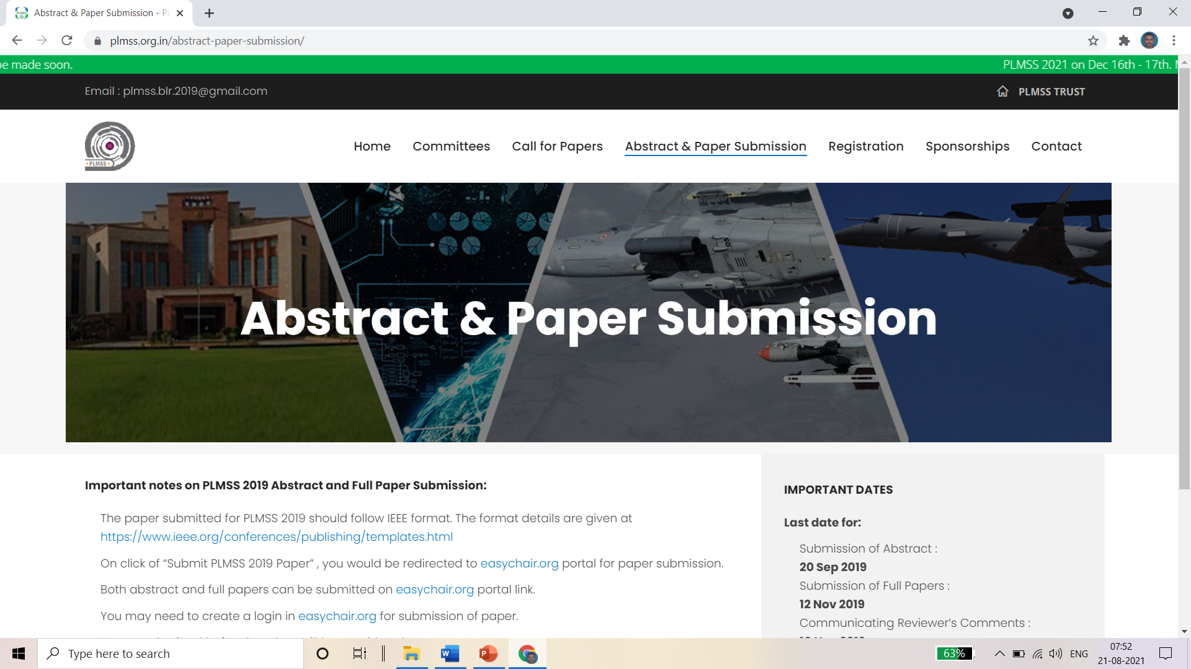
Figure 2(a). This is an example layout for the photos.

Figure 2(b). This is an example layout for yourgraph.

Figures and tables must be numbered. Figures and tables captions must be centered in 12 pt with small caps. Captions with figure numbers must be placed after their associated figures, as shown in Figure 1. Captions with table numbers must be placed before their associated tables, as shown in Table I.

- CONCLUSION

- What have you told us? Remind us what the most important point of your STUDY is.
- Succinctly restate your recommendation and tie in these two points:
  - Why should they implement your recommendations?
  - What will be the outcome if the recommendations are implemented successfully? (What will the benefits be?)

Present your conclusions here (and do not use any graphs, figure or table). If you use any references, please give them with authors’ surname and date (Kemal and Sen, 2011). That means that references should be listed in alphabetical order (Yueng, 2015). Journal articles as depicted in the example below should conform to the standard Vancouver style of punctuation, and abbreviations (Kang et al., 2017).

The text of your extended abstract should be minimum 2 pages (including all figures, tables and references). (Important instruction: The title of the extended abstract and the file name must be same.)

We are looking forward to seeing you at the PLMSS2021.

ACKNOWLEDGMENT

Collate acknowledgements in this separate section at the end of the text, before the part of references. List here those individuals who provided help during the research (e.g., funding the project, providing language help, writing assistance or proof reading the article, etc.).

REFERENCES

It is essential that References should be listed alphabetically at the end of the paper. Although "et al." is preferable in the text, in the list of references all authors should be given.

Citations in the text

The abbreviation "et al." (in italics) should be used in the text, when there are more than three authors of a cited paper.

List of references

References should be ordered alphabetically in this list.
The reference information within the text should be set in brackets, thus (Surname,1965).
The reference list should be formatted using 12pt Times New Roman typeface with the first line hanging.

Journal reference style:

Sen, Kemal and Sevimli, F. 2015. Sonochemicalpre-treatment. Eurasian Journal of Environmental Research, 2, 58 - 65.

Other reference styles for book, standard reference, report, thesis:

D. Rood, A Practical Guide to the Care, Maintenance and Troubleshooting of Capillary Gas Chromatographic Systems, Wiley-VCH, Weinheim, 1998.

Standard Methods for the Examination of Water and Wastewater, 1998. 20th edn, American Public Health Association/American Water Works Association/Water Environment Federation, Washington DC, USA.

Sobsey, M.D. and Pfaender, F.K. 2002. Evaluation of the H2S method for Detection of Fecal Contamination of Drinking Water, Report WHO/SDE/WSH/02.08, Water Sanitation and Health Programme, WHO, Geneva, Switzerland.

Sourney, S. 2014. Effects of US Pre-treatment on Wines, PhD Thesis, Department of Food Engineering, Graduate School of Natural and Applied Sciences, SCD University, Nevsehir, Turkey.

Use surname of author and year of publication: Jones (2002) or (Jones, 2002).

Insert initials only if there are two different authors with the same surname and same year of publication.

Two or more years in parentheses following an author's name are cited in ascending order of year, and two or more references published in the same year by the same author are differentiated by letters a, b, c, etc. For example: Sen (1999, 2002, 2003a, b).

Different references cited together should be in date order, for example: (Sen, 2009; Sen&Ng, 2013; Yhou, 2015).

If a paper has been accepted for publication but has not been published the term "(in press)" should be used instead of a date. If a paper has been submitted but not definitely accepted the term "(submitted)" should be used. If the paper is still being prepared the term "(in preparation)" should be used. The abbreviation "et al." should be used in the text when there are more than two co-authors of a cited paper. Please double-check: every citation in the text must match up to an entry in the reference list.

